**Data Collection SpaceXAPI**

Lab 1: Collecting the data

Estimated time needed: **45** minutes

In this capstone, we will predict if the Falcon 9 first stage will land successfully. SpaceX advertises Falcon 9 rocket launches on its website with a cost of 62 million dollars; other providers cost upward of 165 million dollars each, much of the savings is because SpaceX can reuse the first stage. Therefore if we can determine if the first stage will land, we can determine the cost of a launch. This information can be used if an alternate company wants to bid against SpaceX for a rocket launch. In this lab, you will collect and make sure the data is in the correct format from an API. The following is an example of a successful and launch.



Several examples of an unsuccessful landing are shown here:



Most unsuccessful landings are planned. Space X performs a controlled landing in the oceans.

Objectives

In this lab, you will make a get request to the SpaceX API. You will also do some basic data wrangling and formating.

* Request to the SpaceX API
* Clean the requested data

Import Libraries and Define Auxiliary Functions

We will import the following libraries into the lab

# Requests allows us to make HTTP requests which we will use to get data from an API

import requests

# Pandas is a software library written for the Python programming language for data manipulation and analysis.

import pandas as pd

# NumPy is a library for the Python programming language, adding support for large, multi-dimensional arrays and matrices, along with a large collection of high-level mathematical functions to operate on these arrays

import numpy as np

# Datetime is a library that allows us to represent dates

import datetime

# Setting this option will print all collumns of a dataframe

pd.set_option('display.max_columns', None)

# Setting this option will print all of the data in a feature

pd.set_option('display.max_colwidth', None)

Below we will define a series of helper functions that will help us use the API to extract information using identification numbers in the launch data.

From the rocket column we would like to learn the booster name.

# Takes the dataset and uses the rocket column to call the API and append the data to the list

def getBoosterVersion(data):

for x in data['rocket']:

if x:

response = requests.get("https://api.spacexdata.com/v4/rockets/"+str(x)).json()

BoosterVersion.append(response['name'])

Then

# Takes the dataset and uses the rocket column to call the API and append the data to the list

def getBoosterVersion(data):

for x in data['rocket']:

if x:

response = requests.get("https://api.spacexdata.com/v4/rockets/"+str(x)).json()

BoosterVersion.append(response['name'])

#From the <code>launchpad</code> we would like to know the name of the launch site being used, the longitude, and the latitude.

Then

# Takes the dataset and uses the launchpad column to call the API and append the data to the list

def getLaunchSite(data):

for x in data['launchpad']:

if x:

response = requests.get("https://api.spacexdata.com/v4/launchpads/"+str(x)).json()

Longitude.append(response['longitude'])

Latitude.append(response['latitude'])

LaunchSite.append(response['name'])

From the payload we would like to learn the mass of the payload and the orbit that it is going to.

# Takes the dataset and uses the payloads column to call the API and append the data to the lists

def getPayloadData(data):

for load in data['payloads']:

if load:

response = requests.get("https://api.spacexdata.com/v4/payloads/"+load).json()

PayloadMass.append(response['mass_kg'])

Orbit.append(response['orbit'])

From cores we would like to learn the outcome of the landing, the type of the landing, number of flights with that core, whether gridfins were used, whether the core is reused, whether legs were used, the landing pad used, the block of the core which is a number used to separate version of cores, the number of times this specific core has been reused, and the serial of the core.

# Takes the dataset and uses the cores column to call the API and append the data to the lists

def getCoreData(data):

for core in data['cores']:

if core['core'] != None:

response = requests.get("https://api.spacexdata.com/v4/cores/"+core['core']).json()

Block.append(response['block'])

ReusedCount.append(response['reuse_count'])

Serial.append(response['serial'])

else:

Block.append(None)

ReusedCount.append(None)

Serial.append(None)

Outcome.append(str(core['landing_success'])+' '+str(core['landing_type']))

Flights.append(core['flight'])

GridFins.append(core['gridfins'])

Reused.append(core['reused'])

Legs.append(core['legs'])

LandingPad.append(core['landpad'])

Now let's start requesting rocket launch data from SpaceX API with the following URL:

spacex_url=<https://api.spacexdata.com/v4/launches/past>

Then

response = requests.get(spacex_url)

Check the content of the response

print(response.content)

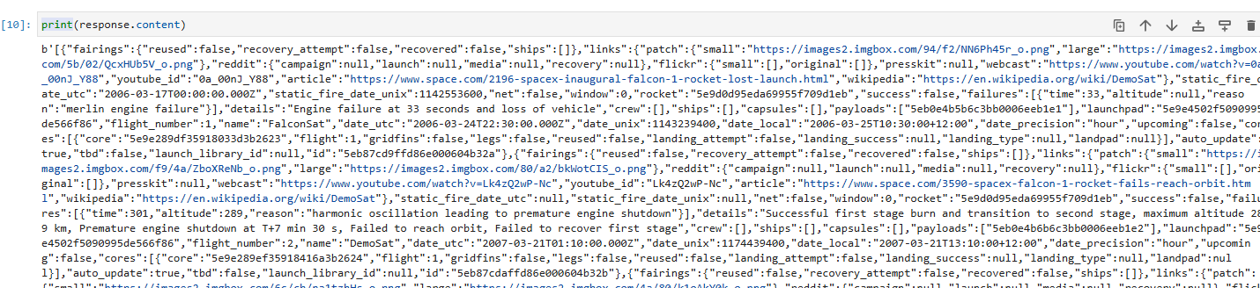

You should see the response contains massive information about SpaceX launches. Next, let's try to discover some more relevant information for this project.

Task 1: Request and parse the SpaceX launch data using the GET request

To make the requested JSON results more consistent, we will use the following static response object for this project:

static_json_url='https://cf-courses-data.s3.us.cloud-object-storage.appdomain.cloud/IBM-DS0321EN-SkillsNetwork/datasets/API_call_spacex_api.json'

We should see that the request was successful with the 200 status response code

response=requests.get(static_json_url)

Then

response.status_code

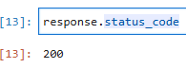

Now we decode the response content as a Json using .json() and turn it into a Pandas dataframe using .json_normalize()

# Use json_normalize meethod to convert the json result into a dataframe

# Use json_normalize meethod to convert the json result into a dataframe

data = pd.json_normalize(response.json())

Using the dataframe data print the first 5 rows

# Get the head of the dataframe

print("The first 5 rows of the dataframe")

data.head(5)

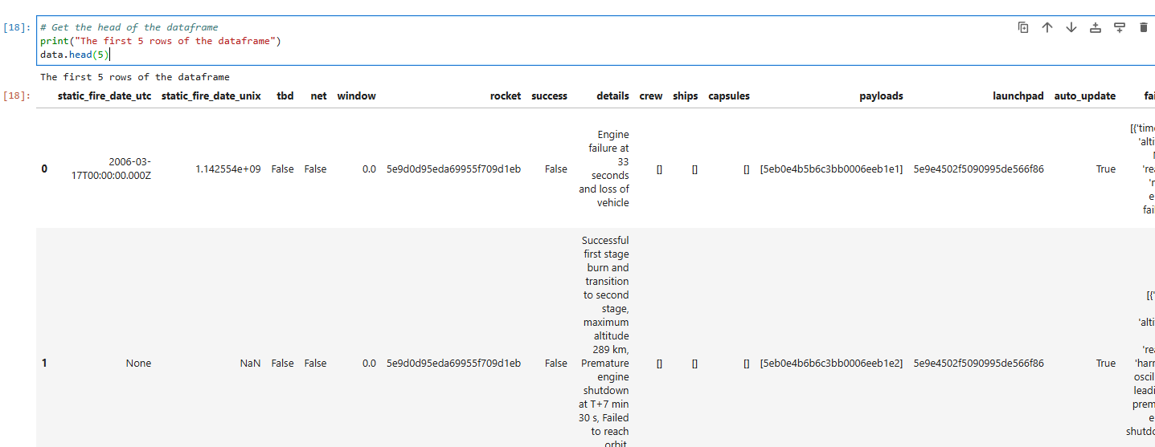

You will notice that a lot of the data are IDs. For example, the rocket column has no information about the rocket just an identification number.

We will now use the API again to get information about the launches using the IDs given for each launch. Specifically, we will be using columns rocket, payloads, launchpad, and cores.

# Lets take a subset of our dataframe keeping only the features we want and the flight number, and date_utc.

data = data[['rocket', 'payloads', 'launchpad', 'cores', 'flight_number', 'date_utc']]

# We will remove rows with multiple cores because those are falcon rockets with 2 extra rocket boosters and rows that have multiple payloads in a single rocket.

data = data[data['cores'].map(len)==1]

data = data[data['payloads'].map(len)==1]

# Since payloads and cores are lists of size 1 we will also extract the single value in the list and replace the feature.

data['cores'] = data['cores'].map(lambda x : x[0])

data['payloads'] = data['payloads'].map(lambda x : x[0])

# We also want to convert the date_utc to a datetime datatype and then extracting the date leaving the time

data['date'] = pd.to_datetime(data['date_utc']).dt.date

# Using the date we will restrict the dates of the launches

data = data[data['date'] <= datetime.date(2020, 11, 13)]

* From the rocket we would like to learn the booster name
* From the payload we would like to learn the mass of the payload and the orbit that it is going to
* From the launchpad we would like to know the name of the launch site being used, the longitude, and the latitude.
* **From cores we would like to learn the outcome of the landing, the type of the landing, number of flights with that core, whether gridfins were used, whether the core is reused, whether legs were used, the landing pad used, the block of the core which is a number used to separate version of cores, the number of times this specific core has been reused, and the serial of the core.**

The data from these requests will be stored in lists and will be used to create a new dataframe.

#Global variables

BoosterVersion = []

PayloadMass = []

Orbit = []

LaunchSite = []

Outcome = []

Flights = []

GridFins = []

Reused = []

Legs = []

LandingPad = []

Block = []

ReusedCount = []

Serial = []

Longitude = []

Latitude = []

These functions will apply the outputs globally to the above variables. Let's take a looks at BoosterVersion variable. Before we apply getBoosterVersion the list is empty:

BoosterVersion

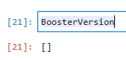

Now, let's apply  getBoosterVersion function method to get the booster version

# Call getBoosterVersion

getBoosterVersion(data)

the list has now been updated

BoosterVersion[0:5]

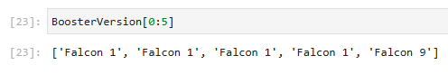

we can apply the rest of the functions here:

# Call getLaunchSite

getLaunchSite(data)

Then

# Call getPayloadData

getPayloadData(data)

Then

# Call getCoreData

getCoreData(data)

Finally lets construct our dataset using the data we have obtained. We combine the columns into a dictionary.

launch_dict = {'FlightNumber': list(data['flight_number']),

'Date': list(data['date']),

'BoosterVersion':BoosterVersion,

'PayloadMass':PayloadMass,

'Orbit':Orbit,

'LaunchSite':LaunchSite,

'Outcome':Outcome,

'Flights':Flights,

'GridFins':GridFins,

'Reused':Reused,

'Legs':Legs,

'LandingPad':LandingPad,

'Block':Block,

'ReusedCount':ReusedCount,

'Serial':Serial,

'Longitude': Longitude,

'Latitude': Latitude}

Then, we need to create a Pandas data frame from the dictionary launch_dict.

# Create a data frame from launch_dict

df = pd.DataFrame(launch_dict)

Show the summary of the dataframe

# Show the head of the dataframe

df.head(5)

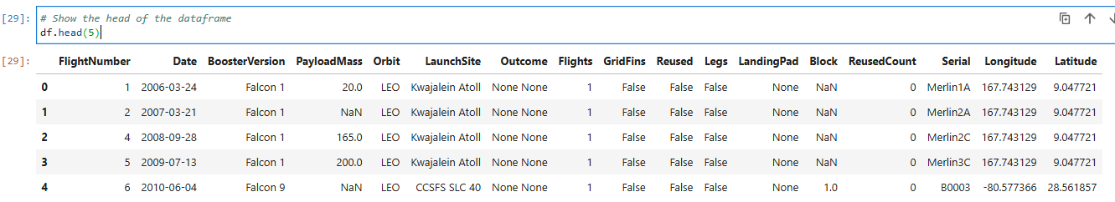

Task 2: Filter the dataframe to only include Falcon 9 launches

Finally we will remove the Falcon 1 launches keeping only the Falcon 9 launches. Filter the data dataframe using the BoosterVersion column to only keep the Falcon 9 launches. Save the filtered data to a new dataframe called data_falcon9.

#create a new dataframe called data_falcon9

data_falcon9 = df[df['BoosterVersion'] == 'Falcon 9'].copy()

Now that we have removed some values we should reset the FlightNumber column

#Reset the FlightNumber column

data_falcon9.loc[:,'FlightNumber'] = list(range(1, data_falcon9.shape[0]+1))

data_falcon9

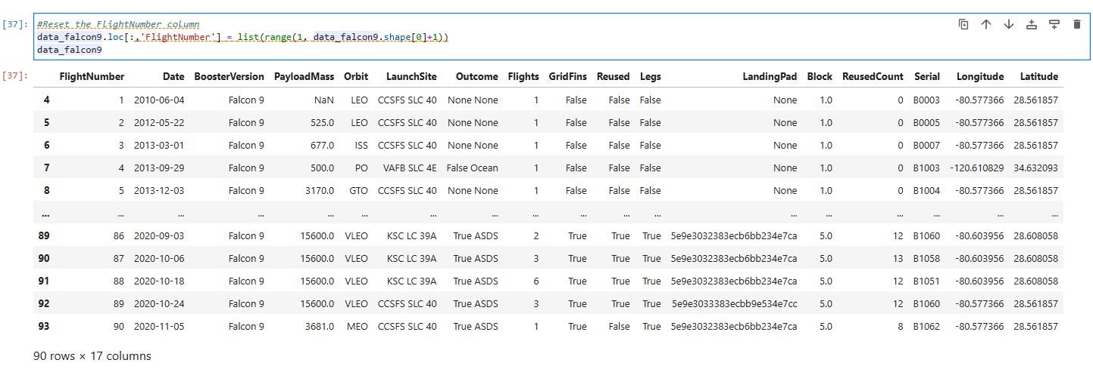

Data Wrangling

We can see below that some of the rows are missing values in our dataset.

data_falcon9.isnull().sum()

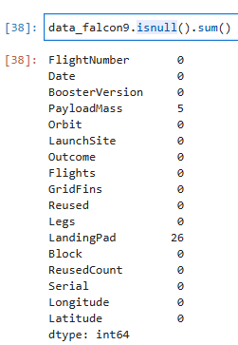

Before we can continue we must deal with these missing values. The LandingPad column will retain None values to represent when landing pads were not used.

Task 3: Dealing with Missing Values

Calculate below the mean for the PayloadMass using the .mean(). Then use the mean and the .replace() function to replace np.nan values in the data with the mean you calculated.

# Calculate the mean value of PayloadMass column

avg_payload = data_falcon9['PayloadMass'].astype('float').mean(axis=0)

# Replace the np.nan values with its mean value

data_falcon9['PayloadMass'].replace(np.nan, avg_payload, inplace=True)

You should see the number of missing values of the PayLoadMass change to zero.

Now we should have no missing values in our dataset except for in LandingPad.

We can now export it to a **CSV** for the next section,but to make the answers consistent, in the next lab we will provide data in a pre-selected date range.

data_falcon9.to_csv('dataset_part_1.csv', index=False)